Analysis On Toy Manufacturers In US States By Index
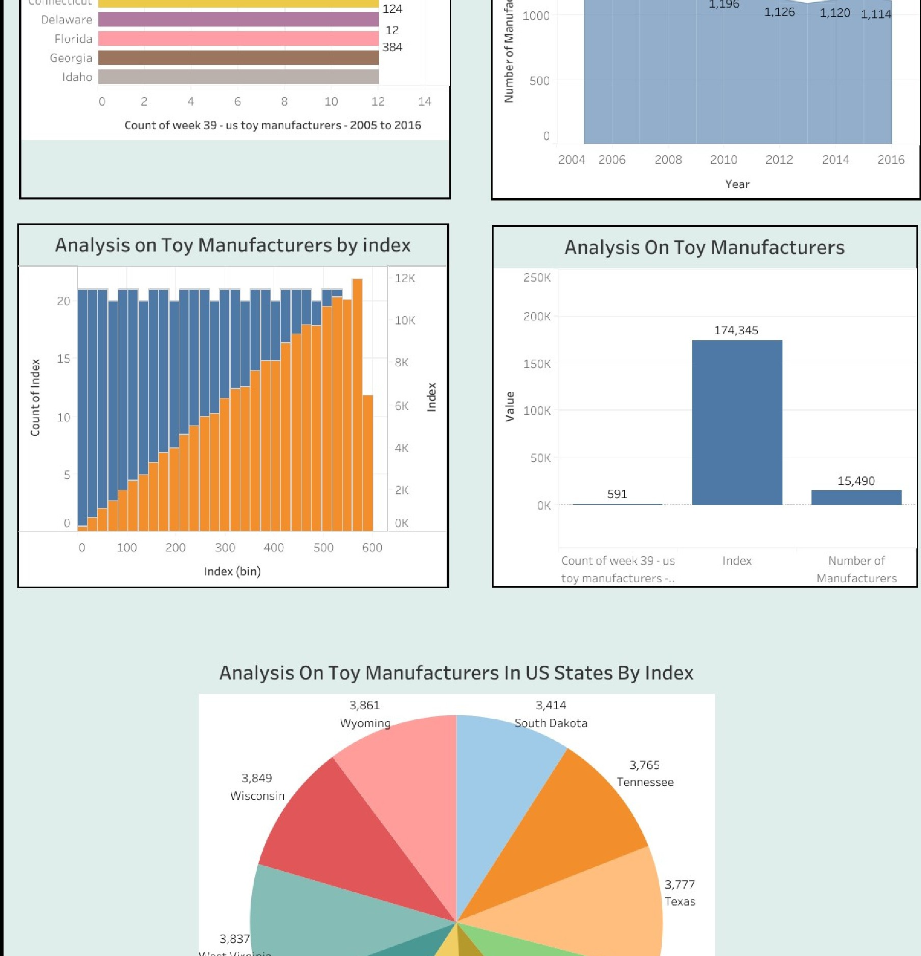
3i•414
3,777
Texas

